Display skills of Operators with rating

In order to display this we need to create one report under data-admin-operator-ID and then go for the class join with index-operator skills and then add the filter of the skill is French and then use a function of integer to text and then get the value rating of the operators.

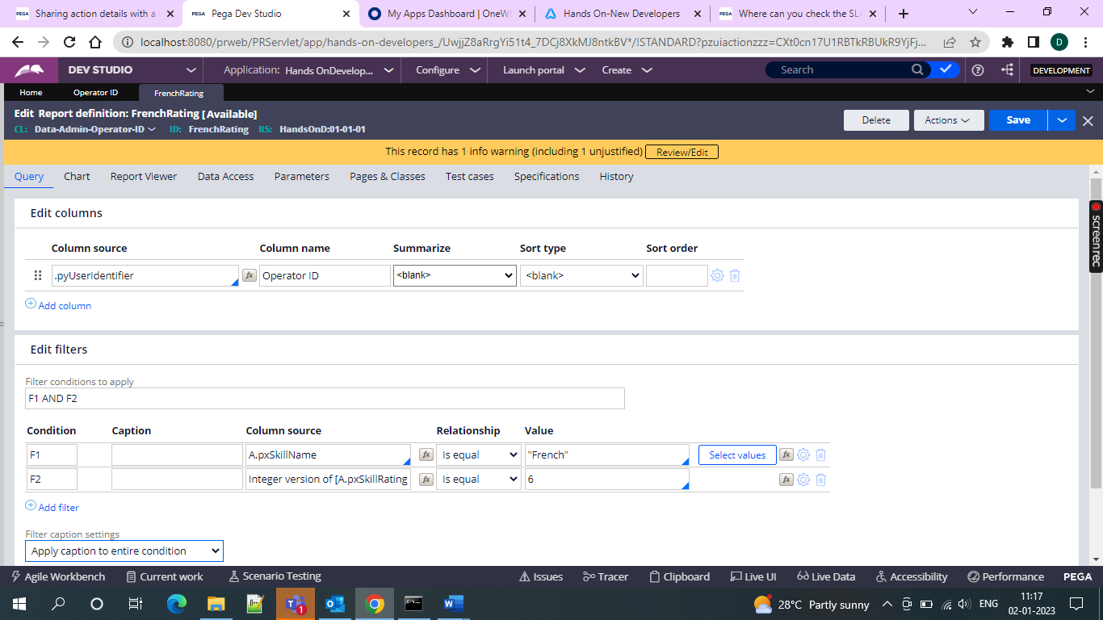

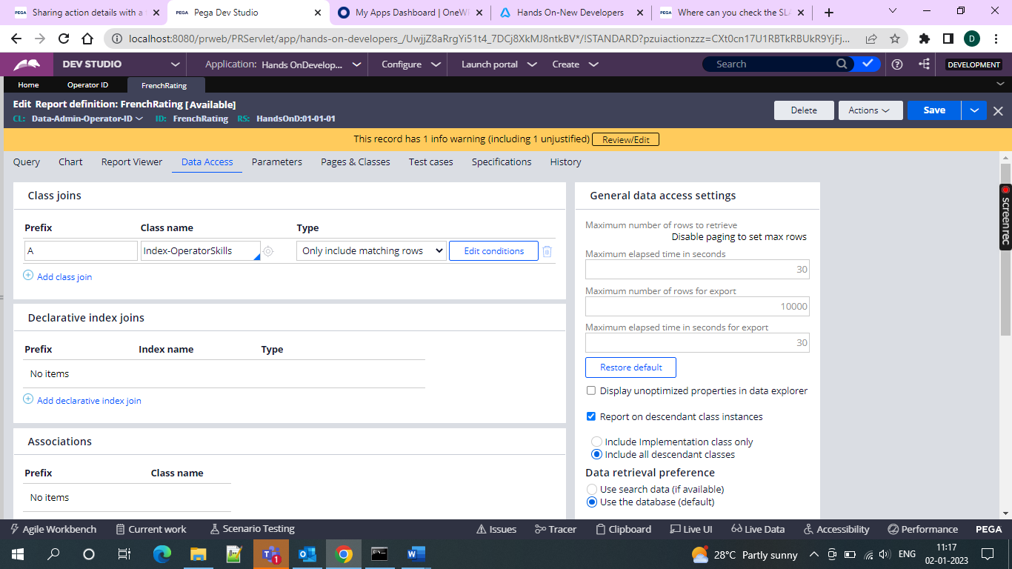

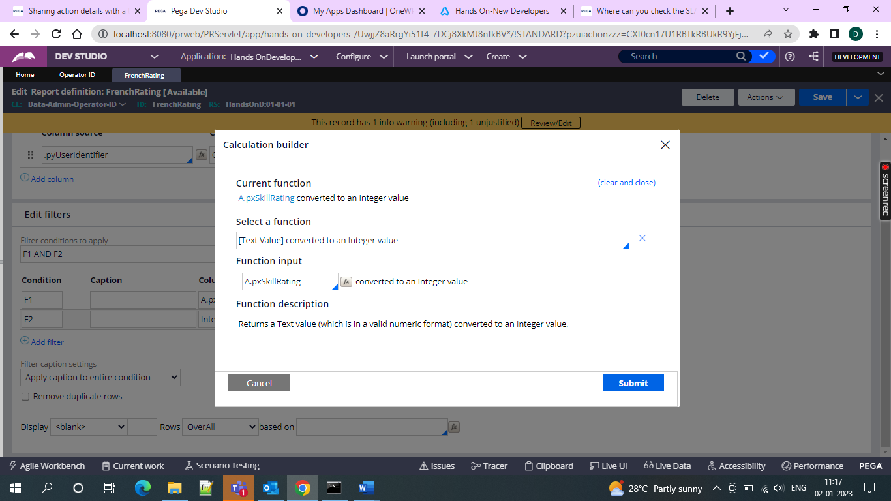

And then we can get the operators with French skill rating

